* Homeostasis = s table environment
* Cell membrane helps keep homeostasis by controlling what enters and leaves a cell
* Cell membrane is made of a phospholipid bilayer
* The two layers have head that is polar and a tail which is non - polar 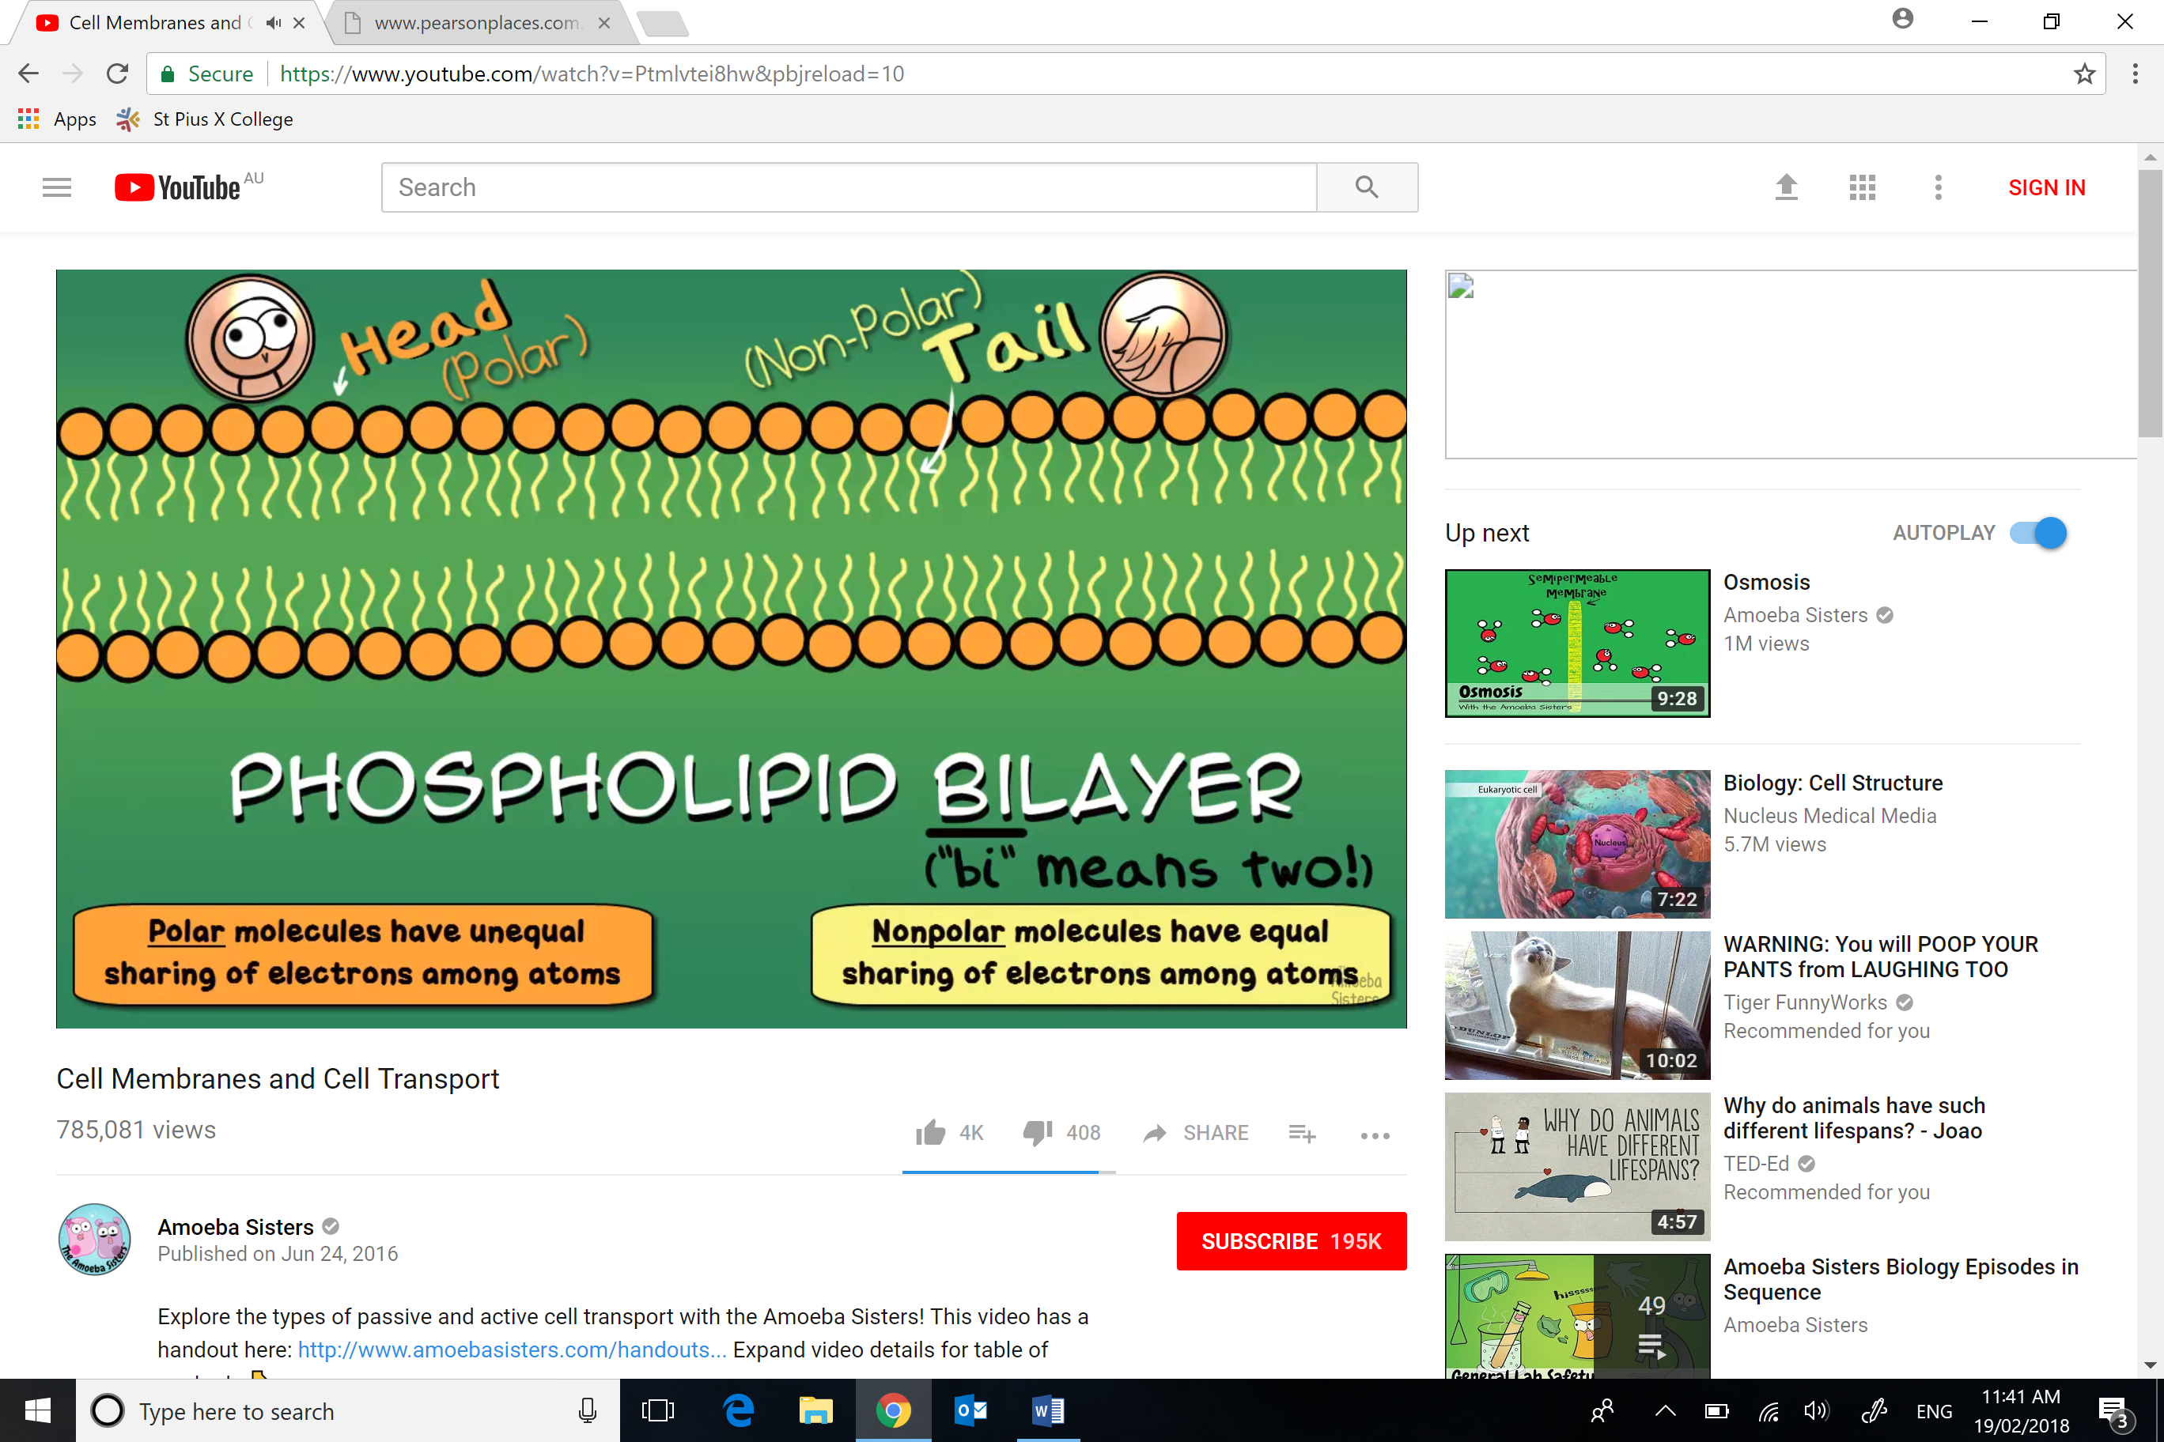
* Small non-polar molecule pass through the lipid layer (known as Simple Diffusion)
* Simple diffusion requires no energy, meaning it is a form of passive transport
* The molecules naturally move from areas of low concentration to areas of high concentration
* The concentration gradient is a reference to the ratio of the molecule on each side of the membrane
* In the membrane there are proteins, some are called transport proteins
* Transport proteins aid in letting specific molecules enter the cell. This process is called facilitative diffusion
* Facilitative diffusion is a form passive transportation as it requires no energy
* For water to travel quickly into the cell (that is faster than osmosis) a special protein aquaporins
* ATP is adenosine triphosphate – Used for a force as when the third phosphate is broken it releases energy
* ATP is used to power active transport
* Sometimes a substance needs to fuse with the cell membrane to take them inside the cell, this is called endocytosis
* The reverse procedure of this, fusing to get molecules out the cell is called exocytosis
* An example of exocytosis is that in plant cells to build the cell wall, the material required for this are synthesised internally, and thus need exocytosis to get these materials to the outside of the membrane.